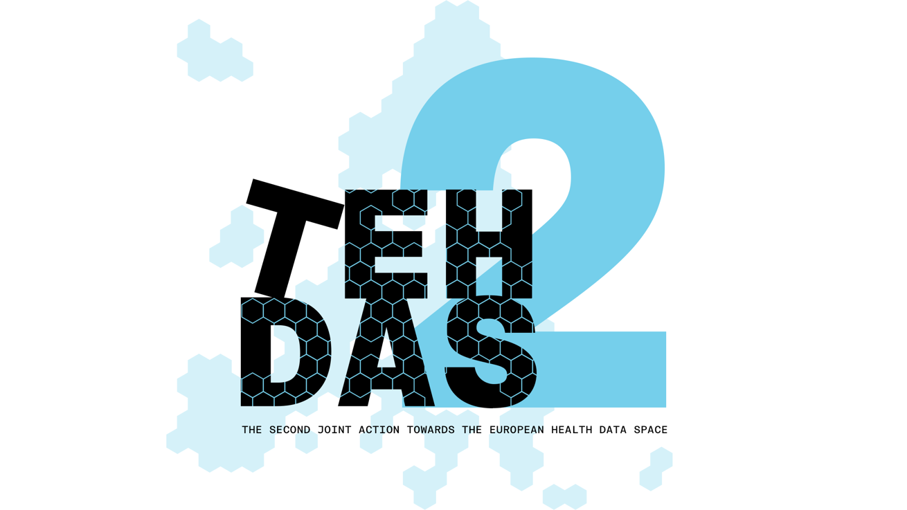

M8.4 Draft guideline for data users on handling research outcomes – public consultation questions
TEHDAS2 – Second Joint Action Towards the European Health Data Space

14 April 2026

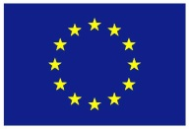
Co-funded by
the European Union
0 Document info

Disclaimer
Views and opinions expressed in this deliverable represent those of the author(s) only and do not necessarily reflect those of the European Union or HaDEA. Neither the European Union nor the granting authority can be held responsible for them.

Copyright Notice
Copyright © 2024 TEHDAS2 Consortium Partners. All rights reserved. For more information on the project, please see www.tehdas.eu.

Introduction
By committing to a rigorous public consultation process, the TEHDAS2 project ensures that its deliverables are not only compliant with regulatory requirements but also practical, feasible, and supported by the community they are intended to serve.

Part A questions for generic feedback
These questions will be asked in each public consultation to provide an understanding of the recipients’ demographics, the quality of the document and to gather generic feedback. Questions marked with an asterisk are mandatory.

Demography
Country* [-List of countries-, EEA (Iceland, Liechtenstein and Norway, Europe non-EEA,European Organisation (European Commission, EMA, etc.), International Organisation (UN, WHO, etc.), Other]
Type of the responder* [Public organisation, Private organisation, Non-governmental organisation (NGO), Academic or research institution, Interest group, Individual expert or professional, Patient representative, Individual citizen, Other]
Are you responding on behalf of several organisations?* Yes/No
If yes: On behalf of how many organisations?
Sector* [Health care provider, Health care administration, Government/public administration, Research and development, Manufacturer of medical devices, Pharmaceutical industry, Education and academia, Information technology, Data management/processing, Patient advocacy, Legal and compliance, Information & media, Other]
Organisation size* [Micro (1–9 employees), Small to medium enterprise (10–249 employees), Large enterprise (250+ employees), Not applicable/Individual citizen
Professional role/function [open text field]

Quality
Is the document easy to understand?* [Rate 1 (Not clear nor easy to understand) – 4 (Very clear and easy to understand)]
How well does the document address the key issues and challenges related to its subject matter?* [Rate 1 (Not well) – 4 (Very well)]
How feasible do you find the guidelines or technical specifications presented in the document?* [Rate 1 (Not feasible at all) – 4 (Very feasible)]

Generic feedback
Do you have any suggestions for improving the document? Are there any additional topics or areas that should be covered? [Please provide feedback and ideas for enhancing the document] [max. 5000 characters]

Part B questions for specific feedback

- Is the scope and aim of the guidance clearly described in the Introduction (i.e. handling of research and innovation outcomes under the EHDS)?
[Yes / No – please explain]

- Are the key concepts (e.g. “outcomes”, “results”, “outputs”) clearly defined and used consistently throughout the document?
[Yes / No – please explain]

- Is the intended target audience (secondary data users) clearly identified and consistently addressed throughout the document?
[Yes / No – please explain]

- Is the relationship between the EHDS Regulation and the GDPR for secondary data users explained in a clear and legally accurate manner?
[Yes / No – please explain]

- Does the document clearly distinguish between legally binding obligations and non-binding recommendations or good practices?
[Yes / No – please explain]

- Are lawful bases for processing, accountability, and controller responsibilities of secondary data users sufficiently clear and accurate?
[Yes / No – please explain]

- Are the roles and responsibilities of secondary data users, HDABs, and health data holders clearly distinguished particularly with regard to outcome handling, reporting, and dissemination?
[Yes / No – please explain]

- Does the document appropriately integrate ethical standards (e.g. research ethics, public interest, proportionality) into guidance on outcome handling?
[Yes / No – please explain]

- Is the guidance on clinically significant findings sufficiently clear, accurate and actionable for secondary data users?
[Yes / No – please explain]

- Are governance boundaries (prohibition of re-identification, notification via HDABs, role of data holders) clearly and consistently respected?
[Yes / No – please explain]

- Are the constraints related to secure processing environments (e.g. output control, export limitations) realistically reflected and manageable in practice?
[Yes / No – please explain]

- Does the document strike an appropriate balance between enabling innovation/IP generation and safeguarding transparency, public interest and EHDS objectives?
[Yes / No – please explain]

- Are expectations regarding transparency and reporting of commercially relevant outcomes clear and proportionate and correctly limited to what is required under the EHDS framework?
[Yes / No – please explain]

- Are dissemination and reporting obligations for research, policy, and outcomes related to product or service development (Article 47 EHDS) clearly described?
[Yes / No – please explain]

- Do you consider the proposed timelines and reporting practices realistic and feasible for secondary data users in practice?
[Yes / No – please explain]

- Is the guidance on data sharing and collaboration aligned with EHDS governance and sufficiently clear for secondary data users?
[Yes / No – please explain]

- Are cross-border and international collaboration aspects adequately addressed, in line with the responsibilities of secondary data users under the EHDS?
[Yes / No – please explain]

- Do you expect this guidance to have a practical impact on your organisation’s or your own activities as a secondary data user under the EHDS?
[Yes / No – please explain]

- Which sections of the document, if any, require the most improvement before finalisation?
[Free text]

- Any additional comments or concerns regarding the handling of research outcomes under the EHDS that are not covered above?
[Free text]

