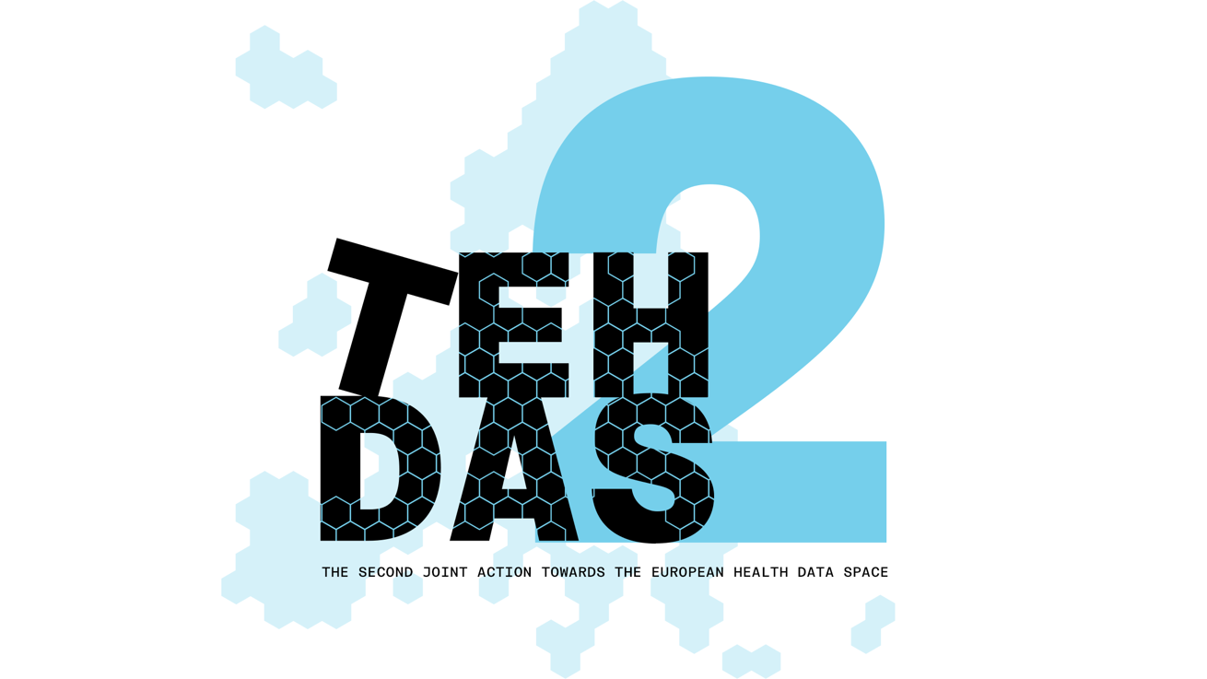

M8.2 Draft Guideline for Health Data Access Bodies on informing natural persons about the use of health data – “Citizen Information Point” – public consultation questions

TEHDAS2 – Second Joint Action Towards the European Health Data Space

21 April 2026

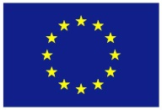
Co-funded by
the European Union

0 Document info

Disclaimer
Views and opinions expressed in this deliverable represent those of the author(s) only and do not necessarily reflect those of the European Union or HaDEA. Neither the European Union nor the granting authority can be held responsible for them.

Copyright Notice
Copyright © 2024 TEHDAS2 Consortium Partners. All rights reserved. For more information on the project, please see www.tehdas.eu.

1 Introduction
By committing to a rigorous public consultation process, the TEHDAS2 project ensures that its deliverables are not only compliant with regulatory requirements but also practical, feasible, and supported by the community they are intended to serve.

1.1 Part A questions for generic feedback
These questions will be asked in each public consultation to provide an understanding of the recipients’ demographics, the quality of the document and to gather generic feedback. Questions marked with an asterisk are mandatory.

Demography
Country* [-List of countries-, EEA (Iceland, Liechtenstein and Norway, Europe non-EEA,European Organisation (European Commission, EMA, etc.), International Organisation (UN, WHO, etc.), Other]
Type of the responder* [Public organisation, Private organisation, Non-governmental organisation (NGO), Academic or research institution, Interest group, Individual expert or professional, Patient representative, Individual citizen, Other]
Are you responding on behalf of several organisations?* Yes/No
If yes: On behalf of how many organisations?
Sector* [Health care provider, Health care administration, Government/public administration, Research and development, Manufacturer of medical devices, Pharmaceutical industry, Education and academia, Information technology, Data management/processing, Patient advocacy, Legal and compliance, Information & media, Other]
Organisation size* [Micro (1–9 employees), Small to medium enterprise (10–249 employees), Large enterprise (250+ employees), Not applicable/Individual citizen
Professional role/function [open text field]

Quality
Is the document easy to understand?* [Rate 1 (Not clear nor easy to understand) – 4 (Very clear and easy to understand)]
How well does the document address the key issues and challenges related to its subject matter?* [Rate 1 (Not well) – 4 (Very well)]
How feasible do you find the guidelines or technical specifications presented in the document?* [Rate 1 (Not feasible at all) – 4 (Very feasible)]

Generic feedback
Do you have any suggestions for improving the document? Are there any additional topics or areas that should be covered? [Please provide feedback and ideas for enhancing the document] [max. 5000 characters]

Part B Questions for specific feedback
[All following questions are mandatory]

Generic questions
Are you currently part of a Health Data Access Body (HDAB) and/or do you expect to have a role in fulfilling HDAB responsibilities under the EHDS Regulation in the future? Multiple choices are possible.*
- Yes, I am currently part of an HDAB
- No, but I expect to take part in HDAB roles/responsibilities in the future
- No, but I work closely with HDABs or support their work
- No, I do not expect to be involved in HDAB responsibilities

How familiar are you with national requirement of health information portals?*
- Not at all
- Some knowledge
- Advanced knowledge on some aspects
- Advanced knowledge on all aspects

Will this guideline impact your organisation or activities?*
[Yes / No – please explain]

Guideline structure and readability
Is the scope and aim of the guideline clearly described?*
[Yes / No – please explain]

What are your thoughts on the terminology used in the document? Is it clear and appropriate for the context? Please explain your answer.*
[Open text answer]

Is the overall structure of the guideline (e.g. division into mandatory and optional information) helpful for HDABs setting up a citizen information point?*
[Yes / Somewhat / No – please explain]

Are the responsibilities of HDABs well distinguished from optional features, good practices and other non-mandatory considerations? If not, please explain your answer.*
[Yes / No – please explain]

Do you see any challenges in setting up the citizen information point when following the guideline?*
[Yes / No – please explain]

Guideline content, implementation feasibility
To what extent does the guideline provide a helpful and feasible interpretation of Article 58 of the EHDS Regulation?*
Please rate on a scale of 1 to 4, where 1 means “not at all” and 4 means “to a large extent”.

Do the implementation considerations in the document reflect the purpose of CIPs to provide easily accessible information about secondary use of health data to citizens?*
(Yes/No > What changes or additions would help?)

Does the guideline sufficiently account for accessibility for a diverse audience?*
(Yes/No > What changes or additions would help?)

Are there any legal, ethical or procedural issues that remain unclear or unresolved in the current version of the guideline?*
- Unclear legal issues (Yes > Please explain: / No)
- Unclear ethical issues (Yes > Please explain: / No)
- Unclear procedural issues (Yes > Please explain: / No)

What kind of support would be most helpful for an HDAB to set up a citizen information point according to this guideline?*
Please select all that apply.
- Templates (e.g. for dashboards or text passages)
- A helpdesk or advisory mechanism (EU level) or exchange across HDABs
- More examples in the guideline
- Training or workshops
- Other: (please specify)

What is an information point
How well does the guideline support your understanding of citizen information points?* Please rate on a scale of 1 to 4, where 1 means “not at all” and 4 means “to a large extent”.
- Clarity of definition: scale 1–4,
- Relevance of examples: scale 1–4
- Usefulness of implementation guidance: scale 1–4
- Optional comment or examples:

What information should be provided?
How well does the guideline support your understanding of what information should be provided?*
Please rate on a scale of 1 to 4, where 1 means “not at all” and 4 means “to a large extent”.
- Clarity of definition: scale 1–4,
- Relevance of examples: scale 1–4
- Usefulness of implementation guidance: scale 1–4
- Optional comment or examples:

How should the information be provided?
How well does the guideline support your understanding of how information should be provided?*
Please rate on a scale of 1 to 4, where 1 means “not at all” and 4 means “to a large extent”.
- Clarity of section: scale 1–4,
- Relevance of examples: scale 1–4
- Usefulness of implementation guidance: scale 1–4
- Optional comment or examples:

When should the information be provided?
How well does the guideline support your understanding of when information should be provided?*
Please rate on a scale of 1 to 4, where 1 means “not at all” and 4 means “to a large extent”.
- Clarity of timeline: scale 1–4,
- Relevance of examples: scale 1–4
- Usefulness of implementation guidance: scale 1–4
- Optional comment or examples:

