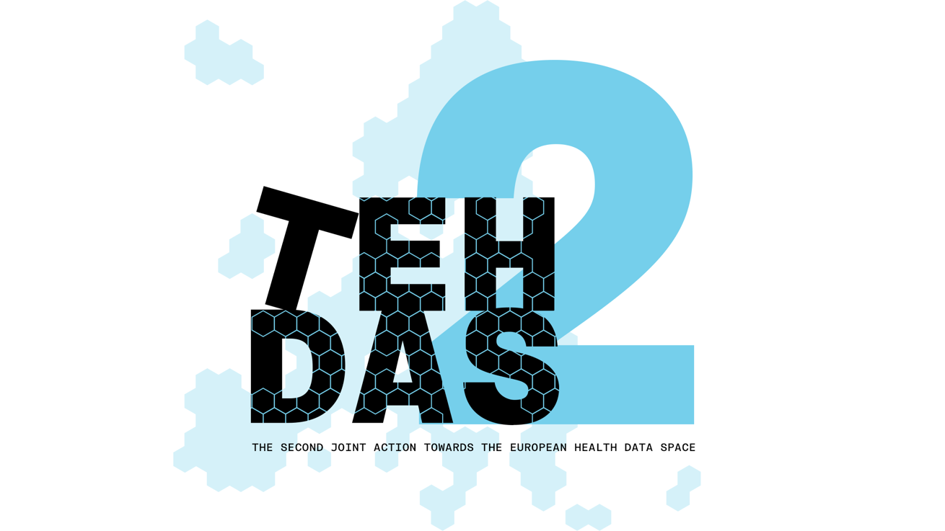

M7.5 Draft guideline on linkage of health datasets – public consultation questions

TEHDAS2 – Second Joint Action Towards the European Health Data Space

31 March 2026

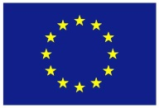
Co-funded by
the European Union

Document info

Disclaimer
Views and opinions expressed in this deliverable represent those of the author(s) only and do not necessarily reflect those of the European Union or HaDEA. Neither the European Union nor the granting authority can be held responsible for them.

Copyright Notice
Copyright © 2024 TEHDAS2 Consortium Partners. All rights reserved. For more information on the project, please see www.tehdas.eu.

Introduction
By committing to a rigorous public consultation process, the TEHDAS2 project ensures that its deliverables are not only compliant with regulatory requirements but also practical, feasible, and supported by the community they are intended to serve.

Part A questions for generic feedback
These questions will be asked in each public consultation to provide an understanding of the recipients’ demographics, the quality of the document and to gather generic feedback. Questions marked with an asterisk are mandatory.

Demography
Country* [-List of countries-, EEA (Iceland, Liechtenstein and Norway, Europe non-EEA,European Organisation (European Commission, EMA, etc.), International Organisation (UN, WHO, etc.), Other]
Type of the responder* [Public organisation, Private organisation, Non-governmental organisation (NGO), Academic or research institution, Interest group, Individual expert or professional, Patient representative, Individual citizen, Other]
Are you responding on behalf of several organisations?* Yes/No
If yes: On behalf of how many organisations?
Sector* [Health care provider, Health care administration, Government/public administration, Research and development, Manufacturer of medical devices, Pharmaceutical industry, Education and academia, Information technology, Data management/processing, Patient advocacy, Legal and compliance, Information & media, Other]
Organisation size* [Micro (1–9 employees), Small to medium enterprise (10–249 employees), Large enterprise (250+ employees), Not applicable/Individual citizen
Professional role/function [open text field]

Quality
Is the document easy to understand?* [Rate 1 (Not clear nor easy to understand) – 4 (Very clear and easy to understand)]
How well does the document address the key issues and challenges related to its subject matter?* [Rate 1 (Not well) – 4 (Very well)]
How feasible do you find the guidelines or technical specifications presented in the document?* [Rate 1 (Not feasible at all) – 4 (Very feasible)]

Generic feedback
Do you have any suggestions for improving the document? Are there any additional topics or areas that should be covered? [Please provide feedback and ideas for enhancing the document] [max. 5000 characters]

Part B questions for specific feedback

- What are you representing, according to the definition of the EHDS Regulation?* [Health Data Access Body (HDAB), Data holder, Trusted data holder, Data User, Trusted third party (TTP), Data protection authority, Secure Processing Environment (SPE) provider, Intermediation entity, Other (please specify in text field)]
Answer type [5] à select all that apply

Topic 1: Why, when, and by whom are data linked?
- On a scale of 1–5, how clear is section 4.1?
Answer type [4]: Values [1-5] (1 = unclear, 2 = rather unclear, 3 = neutral, 4 = rather clear, 5 = very clear)
- Do you have comments for section 4.1 that have not yet been addressed in the generic feedback? The comments can address potential improvements, missing aspects or inconsistencies.
Answer type [1]: max. 5000 characters

Topic 2: What data are being linked?
- On a scale of 1–5, how clear is section 4.2?
Answer type [4]: Values [1-5] (1 = unclear, 2 = rather unclear, 3 = neutral, 4 = rather clear, 5 = very clear)
- Do you have comments for section 4.2 that have not yet been addressed in the generic feedback? The comments can address potential improvements, missing aspects or inconsistencies.
Answer type [1]: max. 5000 characters

Topic 3: How is data linked?
- On a scale of 1–5, how clear is section 4.3?
Answer type [4]: Values [1-5] (1 = unclear, 2 = rather unclear, 3 = neutral, 4 = rather clear, 5 = very clear)
- Do you have comments for section 4.3 that have not yet been addressed in the generic feedback? The comments can address potential improvements, missing aspects or inconsistencies.
Answer type [1]: max. 5000 characters

Topic 4: How is quality and accuracy of linked datasets ensured?
- On a scale of 1–5, how clear is section 4.4?
Answer type [4]: Values [1-5] (1 = unclear, 2 = rather unclear, 3 = neutral, 4 = rather clear, 5 = very clear)
- Do you have comments for section 4.4 that have not yet been addressed in the generic feedback? The comments can address potential improvements, missing aspects or inconsistencies.
Answer type [1]: max. 5000 characters

Topic 5: Role based access to linkage processes
- On a scale of 1–5, how clear is section 5?
Answer type [4]: Values [1-5] (1 = unclear, 2 = rather unclear, 3 = neutral, 4 = rather clear, 5 = very clear)
- Do you have comments for section 5 that have not yet been addressed in the generic feedback? The comments can address potential improvements, missing aspects or inconsistencies.
Answer type [1]: max. 5000 characters
- Do you think there are other topics or questions in the context of data linkage in the EHDS ecosystem for secondary use of health data that should be added or clarified?
Answer type [1]: max. 5000 characters

