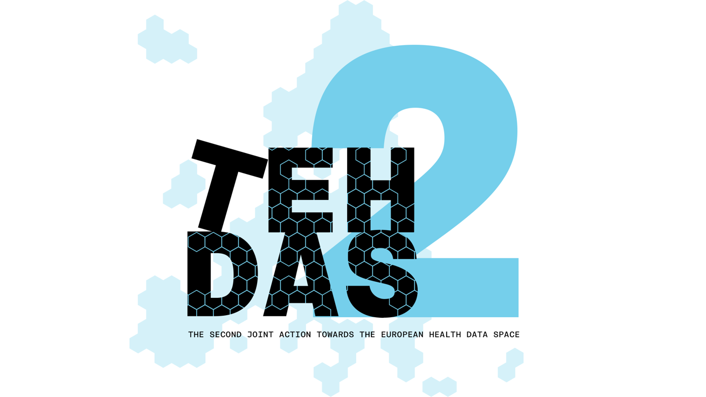

M5.5 Draft Guideline for data user navigating the catalogue – public consultation questions

TEHDAS2 – Second Joint Action Towards the European Health Data Space

Updated 9 May 2026

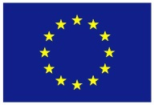
Co-funded by
the European Union

0 Document info

Disclaimer
Views and opinions expressed in this deliverable represent those of the author(s) only and do not necessarily reflect those of the European Union or HaDEA. Neither the European Union nor the granting authority can be held responsible for them.

Copyright Notice
Copyright © 2024 TEHDAS2 Consortium Partners. All rights reserved. For more information on the project, please see www.tehdas.eu.

Introduction
By committing to a rigorous public consultation process, the TEHDAS2 project ensures that its deliverables are not only compliant with regulatory requirements but also practical, feasible, and supported by the community they are intended to serve.

Part A questions for generic feedback
These questions will be asked in each public consultation to provide an understanding of the recipients’ demographics, the quality of the document and to gather generic feedback. Questions marked with an asterisk are mandatory.
Preliminary remark: Before you start reviewing the user guide, please open the page (https://acceptance.data.health.europa.eu/healthdata-central-platform?locale=en) and try to follow the steps and instructions as if you were a non-technical first-time user.

Demography
Country* [-List of countries-, EEA (Iceland, Liechtenstein and Norway, Europe non-EEA,European Organisation (European Commission, EMA, etc.), International Organisation (UN, WHO, etc.), Other]
Type of the responder* [Public organisation, Private organisation, Non-governmental organisation (NGO), Academic or research institution, Interest group, Individual expert or professional, Patient representative, Individual citizen, Other]
Are you responding on behalf of several organisations?* Yes/No
If yes: On behalf of how many organisations?
Sector* [Health care provider, Health care administration, Government/public administration, Research and development, Manufacturer of medical devices, Pharmaceutical industry, Education and academia, Information technology, Data management/processing, Patient advocacy, Legal and compliance, Information & media, Other]
Organisation size* [Micro (1–9 employees), Small to medium enterprise (10–249 employees), Large enterprise (250+ employees), Not applicable/Individual citizen
Professional role/function [open text field]

Quality
Is the document easy to understand?* [Rate 1 (Not clear nor easy to understand) – 4 (Very clear and easy to understand)]
How well does the document address the key issues and challenges related to its subject matter?* [Rate 1 (Not well) – 4 (Very well)]
How feasible do you find the guidelines or technical specifications presented in the document?* [Rate 1 (Not feasible at all) – 4 (Very feasible)]

Generic feedback
Do you have any suggestions for improving the document? Are there any additional topics or areas that should be covered? [Please provide feedback and ideas for enhancing the document] [max. 5000 characters]

Part B questions for specific feedback
Are you currently part of a Health Data Access Body (HDAB) and/or do you expect to have a role in fulfilling HDAB responsibilities under the EHDS Regulation in the future? Multiple choices are possible.

- Yes, I am currently part of an HDAB
- No, but I expect to take part in HDAB roles/responsibilities in the future
- No, but I work closely with HDABs or support their work
- No, I do not expect to be involved in HDAB responsibilities

Have you already had experience with the HealthData@EU Central Platform (https://acceptance.data.health.europa.eu/healthdata-central-platform?locale=en)?
Multiple choices are possible.

- No, this is the first time I've heard of it.
- No, but I've heard/read about it before.
- Yes, I've visited the site at least once.
- Yes, I've already tried out the features provided several times.
- Yes, I was involved in its development.

How usable and practical do you find the guidance?* [Rate 1 (Not usable and practical at all) – 4 (Very usable and practical)]
Did you find the document useful for navigating the central dataset catalogue?* [Rate 1 (Not useful) – 4 (Very useful)]
How clear is the distinction between ‘dataset’ and ‘dataset record’ as presented in the guide?* [Rate 1 (Not clear nor easy to understand) – 4 (Very clear and easy to understand)]

Framework and Infrastructure Understanding
Context: Section 3 of the User Guide and the Quick Guide describe the federated architecture of the EHDS, explaining how national catalogues interact with the central HealthData@EU platform, the overall user journey and provides screenshots of the platform.

On a scale of 1 to 4, how clearly does the User Guide explain the functional distinction between a National Dataset Catalogue and the Central EU Dataset Catalogue?
  - Answer Type: Matrix [1=Not clear at all, 4=Very clear]

Is the explanation regarding the fact that the Central Platform does not store underlying health data sufficiently prominent to manage user expectations?
  - Answer Type: Selection [Radio button: Yes / No]

On a scale of 1 to 4, how helpful is the presentation of the user journey for understanding the user guide and overall orientation?
  - Answer Type: Matrix [1=Not helpful at all, 4=Very helpful]

On a scale of 1 to 4, how well do the screenshots help you to follow the steps described in the user guide?
  - Answer Type: Matrix [1=Poorly, 4=Excellently]

Please provide any suggestions for improving the description of the EHDS infrastructure for non-technical users.
  - Answer Type: Open text field [Max 5000 characters]

Search Functionality and Precision
Context: Section 5 details the mechanisms for locating data, ranging from basic keyword searches to advanced SPARQL queries for machine-readable metadata.

How would you rate the clarity of the instructions for performing a basic keyword search in Section 5.1.1?
  - Answer Type: Matrix [1=Poorly, 4=Excellently]

For advanced users, to what extent do the SPARQL query examples (e.g., Figure 5) assist in understanding how to perform property-based retrieval?
  - Answer Type: Matrix [1=Not helpful at all, 4=Very helpful]

Interpreting Dataset Descriptions (Metadata)
Context: Section 6 and the Quick Guide explain how to assess "Dataset Cards," including content, provenance, and standards like HealthDCAT-AP.

How specific is the guidance in helping you anticipate the procedural burden of a future data application?
  - Answer Type: Matrix [1=Not specific enough, 4=Very specific]

Basket Functionality and Workflow Transition
Context: Section 7 defines the "Basket" as a preparatory tool for shortlisting datasets prior to formal authentication.

Does the guide clearly communicate that adding an item to the "Basket" does not constitute a formal request for data access?
  - Answer Type: Selection [Radio button: Yes / No]

On a scale of 1 to 4, how well does the manual describe the transition from the "pre-authentication workflow" (discovery) to the "post-authentication workflow" (application)?
  - Answer Type: Matrix [1=Very poorly, 4=Very well]

Quick Guide Utility and Visual Aids
Context: The Quick Guide provides a two-page visual overview of the platform's key elements using numbered UI components.

To what extent does the Quick Guide serve as an effective "standalone" document for a first-time user's initial orientation?
  - Answer Type: Matrix [1=Not effective at all, 4=Highly effective]

Is the visual mapping (the use of numbered icons in Figures 1–3) accurately linked to the corresponding textual descriptions in the User Guide?
  - Answer Type: Selection [Radio button: Yes / No]

Use Case Scenarios (Annex 10.4)
Context: The Annex provides tailored scenarios for Healthcare Professionals, Policy Makers, Researchers, and Industry users.

How well does your specific professional profile (e.g., Academic Researcher vs. Industry) align with the search behaviours described in the Use Case Scenarios?
  - Answer Type: Matrix [1=Not at all, 4=Completely]

Which aspect of the Use Case Scenarios did you find most valuable for your understanding? (e.g., filter selection, citing datasets, or identifying standards).
  - Answer Type: Open text field [Max. 5000 characters]

Please provide any suggestions for improving the Use Case Scenarios.
  - Answer Type: Open text field [Max 5000 characters]

Conventions and Terminology
Context: The guide aims for a non-technical tone suitable for CEFR B2-C1 language levels.

Do you find the terminology used (e.g., 'metadata', 'provenance', 'distribution') to be consistently applied and sufficiently explained?
  - Answer Type: Matrix [1=Not consistent at all, 4=Very consistent]

Are there any sections where the academic or technical language acts as a barrier to understanding for non-experts?
  - Answer Type: Open text field [Max. 5000 characters]

