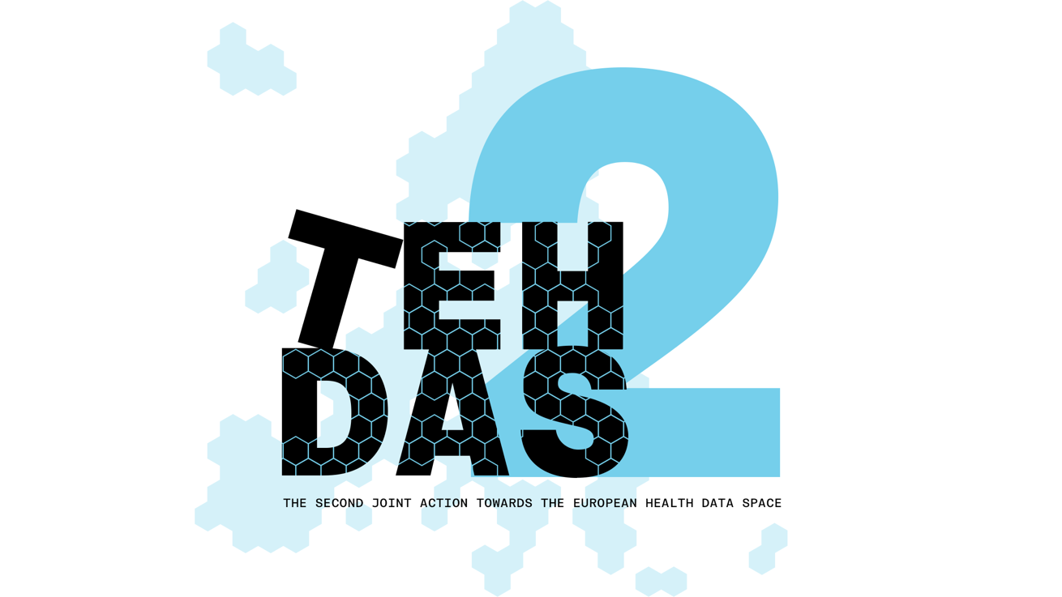

M4.3 Draft guideline for health data access bodies on international and third-country access and transfer of electronic health data – public consultation questions
TEHDAS2 – Second Joint Action Towards the European Health Data Space

19 March 2026

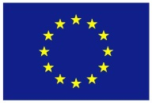
Co-funded by
the European Union

0 Document info

Disclaimer
Views and opinions expressed in this deliverable represent those of the author(s) only and do not necessarily reflect those of the European Union or HaDEA. Neither the European Union nor the granting authority can be held responsible for them.

Copyright Notice
Copyright © 2024 TEHDAS2 Consortium Partners. All rights reserved. For more information on the project, please see www.tehdas.eu.

1 Introduction
By committing to a rigorous public consultation process, the TEHDAS2 project ensures that its deliverables are not only compliant with regulatory requirements but also practical, feasible, and supported by the community they are intended to serve.

1.1 Part A questions for generic feedback
These questions will be asked in each public consultation to provide an understanding of the recipients’ demographics, the quality of the document and to gather generic feedback. Questions marked with an asterisk are mandatory.

1.1.1 Demography
Country* [-List of countries-, EEA (Iceland, Liechtenstein and Norway, Europe non-EEA,European Organisation (European Commission, EMA, etc.), International Organisation (UN, WHO, etc.), Other]
Type of the responder* [Public organisation, Private organisation, Non-governmental organisation (NGO), Academic or research institution, Interest group, Individual expert or professional, Patient representative, Individual citizen, Other]
Are you responding on behalf of several organisations?* Yes/No
If yes: On behalf of how many organisations?
Sector* [Health care provider, Health care administration, Government/public administration, Research and development, Manufacturer of medical devices, Pharmaceutical industry, Education and academia, Information technology, Data management/processing, Patient advocacy, Legal and compliance, Information & media, Other]
Organisation size* [Micro (1–9 employees), Small to medium enterprise (10–249 employees), Large enterprise (250+ employees), Not applicable/Individual citizen
Professional role/function [open text field]

1.1.2 Quality
Is the document easy to understand?* [Rate 1 (Not clear nor easy to understand) – 4 (Very clear and easy to understand)]
How well does the document address the key issues and challenges related to its subject matter?* [Rate 1 (Not well) – 4 (Very well)]
How feasible do you find the guidelines or technical specifications presented in the document?* [Rate 1 (Not feasible at all) – 4 (Very feasible)]

1.1.3 Generic feedback
Do you have any suggestions for improving the document? Are there any additional topics or areas that should be covered? [Please provide feedback and ideas for enhancing the document] [max. 5000 characters]

1.2 Part B questions for specific feedback

Part 1 – Role and experience
- Are you involved in international access to, or transfer of, electronic health data (e.g. as HDAB, data holder, data user, supervisory authority, secure processing environment provider)?*
  - Yes, No

- What are you representing?*
  - Health Data Access Body (HDAB), Data holder, Health data user, Data protection authority or other supervisory authority, Secure Processing Environment (SPE) provider, Research infrastructure, International organisation, Other (please specify)

- How experienced are you with cross‑border or international data access and transfer arrangements (including with third countries or international organisations)?*
  - Rate 1 (no experience; not at all) – 4 (extensive experience; on a regular basis)

- In your current role, have you already been involved in:
  - Assessing international data access requests
  - Drafting/negotiating data transfer agreements
  - Operating or using a secure processing environment for cross‑border access
  - Supervising or auditing international transfers
  - Other (please specify)
  - [Multiple selection + optional text field]

If yes, could you provide examples? (Optional)
[Open text field]

- Do you already rely on specific national rules, internal policies or templates for international access or transfers (beyond the GDPR)?
  - Yes, No, Not sure
  - If yes, please briefly describe. [Open text field]

Part 2 – Clarity of access pathways (authorised participation and reciprocity)
- How clear is the description of the two main access scenarios/pathways (authorised third‑country participation in HealthDataEU or reciprocity‑based access under Article 91(1)(b))?*
  - Rate: 1 (not clear) – 4 (very clear)

- Do you consider that the guideline sufficiently explains the criteria and process for recognising an authorised participant (Article 75(5) in conjunction with Article 91(1)(a))?*
  - Rate :1 (incomplete) – 4 (exhaustive)
  - [Optional: Please explain your rating.] [Text field]

- Is the distinction between access based on authorised participation and access based solely on reciprocity (including the different timelines of application) sufficiently clear for practical implementation?*
  - Rate: 1 (incomplete) – 4 (exhaustive)
  - [Optional: Please explain your rating.] [Text field]

Part 3 – Governance, roles and procedures for HDABs
- To what extent is it clear which tasks and responsibilities fall on the actors (e.g. European Commission, Health Data Access Bodies, National Contact Points) involved in international health data access and transfer scenarios within the EHDS framework?*
  - Rate 1 (not clear at all) – 4 (very clear)

- What challenges do you foresee in implementing the recommended governance arrangements in your national and/or organisational context (e.g. coordination between authorities, resource needs, expertise)?
  - [Open text field]

- Are there in your national and/or organisational context, aspects of governance or institutional cooperation that you consider missing or under‑developed (e.g. interaction with data protection authorities, international coordination, role of research infrastructures)?
  - [Open text field]

Part 4 – Legal framework and interaction with other EU instruments
- Do you consider that the guideline sufficiently addresses the relationship between EHDS rules on international access/transfers and other instruments (e.g. adequacy decisions, standard contractual clauses)?*
  - Rate 1 (incomplete) – 4 (exhaustive)
  - [Optional: Please explain your rating.] [Text field]

- Are there specific legal or interpretative questions that you feel require further clarification in the guideline?
  - [Open text field]

- What legal or regulatory conflicts or overlaps do you foresee when applying the guideline in your jurisdiction (if any)?
  - [Open text field]

Part 5 – Practical usability and implementation challenges
- Overall, how practically useful is the guideline for supporting real‑world decisions on international access to, and transfer of, electronic health data?*
  - Rate 1 (not useful at all) – 4 (very useful)

- Which parts of the guideline do you find the most helpful (e.g. description of scenarios, recommendations section)?
  - [Open text field]

- Which chapters do you find the most difficult to understand? Select one.
Chapter 3 – Survey
Chapter 4 – Scope of the guideline
Chapter 5 – Access application
Chapter 6 – EHDS provisions
Chapter 7 – Interdependencies with other TEHDAS2 deliverables
Chapter 8 - Recommendations
  - [Select one]

- What main implementation challenges do you anticipate in applying the guideline in your organisation or country (e.g. resources, expertise, alignment with national law, cross‑border coordination)?
  - [Open text field]

- Would additional tools or support (e.g. checklists, templates, model clauses, training, case studies) help you in applying the guideline? If yes, please specify which ones.
  - [Open text field]

- Any other comments or suggestions regarding the scope, structure or content of the guideline on international and third‑country access and transfer of electronic health data?
  - [Open text field]

