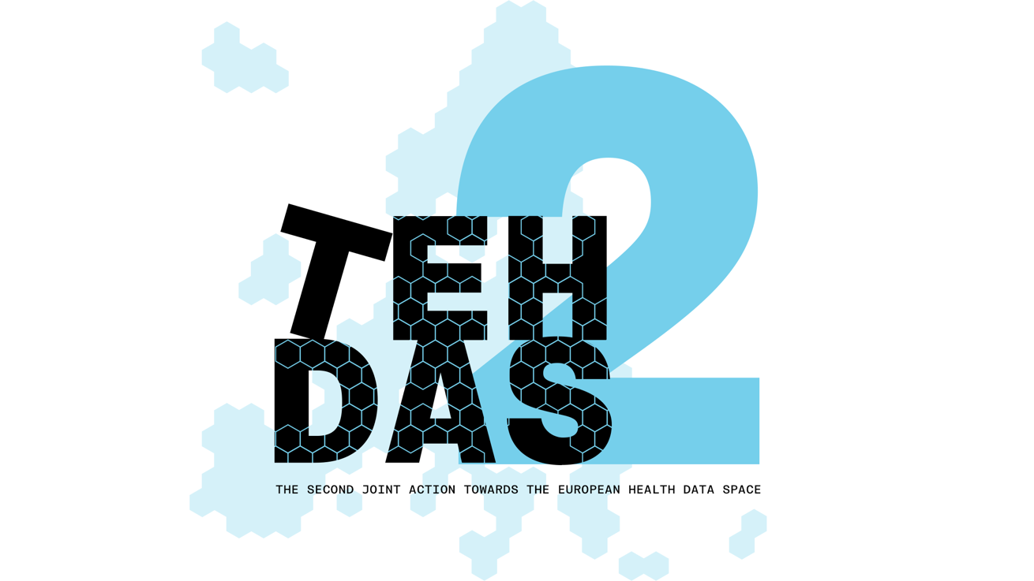

​M4.2 Draft guideline on a framework for collaboration – public consultation questions
TEHDAS2 – Second Joint Action Towards the European Health Data Space

21 April 2026

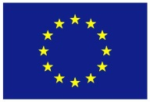
Co-funded by
the European Union
0 Document info

Disclaimer
Views and opinions expressed in this deliverable represent those of the author(s) only and do not necessarily reflect those of the European Union or HaDEA. Neither the European Union nor the granting authority can be held responsible for them.

Copyright Notice
Copyright © 2024 TEHDAS2 Consortium Partners. All rights reserved. For more information on the project, please see www.tehdas.eu.

Introduction
By committing to a rigorous public consultation process, the TEHDAS2 project ensures that its deliverables are not only compliant with regulatory requirements but also practical, feasible, and supported by the community they are intended to serve.

Part A questions for generic feedback
These questions will be asked in each public consultation to provide an understanding of the recipients’ demographics, the quality of the document and to gather generic feedback. Questions marked with an asterisk are mandatory.

Demography
Country* [-List of countries-, EEA (Iceland, Liechtenstein and Norway, Europe non-EEA,European Organisation (European Commission, EMA, etc.), International Organisation (UN, WHO, etc.), Other]
Type of the responder* [Public organisation, Private organisation, Non-governmental organisation (NGO), Academic or research institution, Interest group, Individual expert or professional, Patient representative, Individual citizen, Other]
Are you responding on behalf of several organisations?* Yes/No
If yes: On behalf of how many organisations?
Sector* [Health care provider, Health care administration, Government/public administration, Research and development, Manufacturer of medical devices, Pharmaceutical industry, Education and academia, Information technology, Data management/processing, Patient advocacy, Legal and compliance, Information & media, Other]
Organisation size* [Micro (1–9 employees), Small to medium enterprise (10–249 employees), Large enterprise (250+ employees), Not applicable/Individual citizen
Professional role/function [open text field]

Quality
Is the document easy to understand?* [Rate 1 (Not clear nor easy to understand) – 4 (Very clear and easy to understand)]
How well does the document address the key issues and challenges related to its subject matter?* [Rate 1 (Not well) – 4 (Very well)]
How feasible do you find the guidelines or technical specifications presented in the document?* [Rate 1 (Not feasible at all) – 4 (Very feasible)]

Generic feedback
Do you have any suggestions for improving the document? Are there any additional topics or areas that should be covered? [Please provide feedback and ideas for enhancing the document] [max. 5000 characters]

Part B questions for specific feedback

Part I – Conditions for Collaboration
Topic 1: Ethical governance
- Are there any significant challenges related to ethical governance under the EHDS that are not reflected in this section?

- Do the recommendations on ethical governance adequately address the challenges identified? Are there recommendations you would add or prioritise differently?

Topic 2: Collaboration models and coordination mechanisms
- Are there any significant challenges related to collaboration and coordination under the EHDS that are not reflected in this section?

- Do the recommendations on collaboration models adequately address the challenges identified? Are there recommendations you would add or prioritise differently?

Topic 3: Protection of IP rights and trade secrets
- Are there any significant challenges related to protection of IP rights and trade secrets under the EHDS that are not reflected in this section?
- Do the recommendations on protection of IP rights and trade secrets adequately address the challenges identified? Are there recommendations you would add or prioritise differently?

PART II – Research Infrastructures and Networks in the EHDS
Mapping of services and functions
- Does the mapping of services and functions provided by research infrastructures, networks, and cross-border initiatives in the health data reuse ecosystem feel complete? Are there services, functions, or types of organisations that should be added or better reflected?

Roles and pathways for research infrastructures in the EHDS

- Are the roles and pathways described for research infrastructures in the EHDS context clear and accurate? Do you have any suggestions for how they could be improved or refined?
- Do the observations from stakeholder engagement on role allocation reflect the perspectives of your organisation or community? Are there any additional remarks or perspectives that should be considered?

Recommendations
- Do the recommendations on collaboration models for research infrastructures in the EHDS secondary use framework adequately address the key challenges? Are there recommendations you would add, modify, or prioritise differently?

General remarks
- Does this document adequately address the topic of collaboration in the EHDS secondary use framework? Are there perspectives, actors, or dimensions of collaboration that you feel are missing or should be given greater attention?

