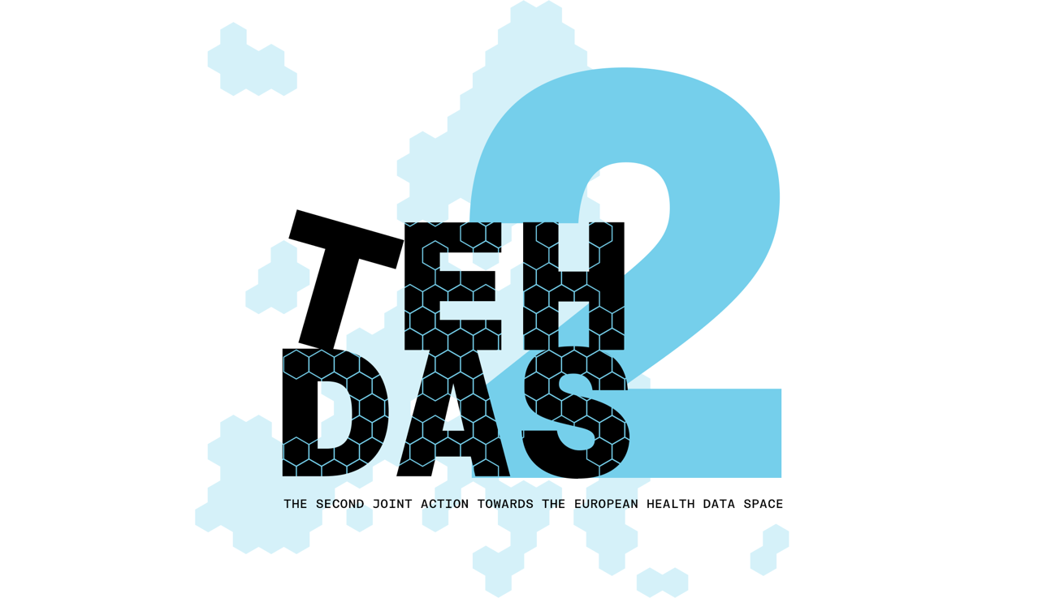

**M7.1: Draft Guideline for data users on how to use data in a secure processing environment – public consultation questions**

TEHDAS2 – Second Joint Action Towards the European Health Data Space

10 January 2025

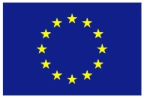**This project has been co-funded by the 4th EU Health Programme (2021–2027) under Grant Agreement no 101176773.**

**Disclaimer**

Views and opinions expressed in this deliverable represent those of the author(s) only and do not necessarily reflect those of the European Union or HaDEA. Neither the European Union nor the granting authority can be held responsible for them.

**Copyright Notice**

Copyright © 2024 TEHDAS2 Consortium Partners. All rights reserved. For more information on the project, please see [www.tehdas.eu](http://www.tehdas.eu).

**Contents**

1 Part A questions for generic feedback 3

1.1 Demography 3

1.1.1 Quality 3

1.2 Generic feedback 4

2 Part B questions for specific feedback 4

# Part A questions for generic feedback

These questions will be asked in each public consultation to provide an understanding of the recipients’ demographics, the quality of the document and to gather generic feedback. Questions marked with an asterisk are mandatory.

## Demography

**Country**\* [-List of countries-, EEA (Iceland, Liechtenstein and Norway, Europe non-EEA,European Organisation (European Commission, EMA, etc.), International Organisation (UN, WHO, etc.), Other]

**Type of the responder**\* [Public organisation, Private organisation, Non-governmental organisation (NGO), Academic or research institution, Interest group, Individual expert or professional, Patient representative, Individual citizen, Other]

**Sector**\* [Health care provider, Health care administration, Government/public administration, Research and development, Manufacturer of medical devices, Pharmaceutical industry, Education and academia, Information technology, Data management/processing, Patient advocacy, Legal and compliance, Information & media, Other]

**Organisation size**\* [Micro (1–9 employees), Small to medium enterprise (10–249 employees), Large enterprise (250+ employees), Not applicable/Individual citizen

**Professional role/function** [open text field]

### Quality

**From your perspective, how ready is the document to meet the expected needs?**\* [Early draft, Major additions/changes needed, Minor additions/changes needed, Only final editorial changes needed]

**What is the level of quality of the document?**\* [Rate 1 (Low) – 4 (Very High)]

**Is the document easy to understand?**\* [Rate 1 (not clear nor easy to understand) – 4 (very clear and easy to understand)]

**How well does the document address the key issues and challenges related to its subject matter?**\* [Rate 1 (not well) – 4 (very well)]

**How feasible and implementable do you find the guidelines or technical specifications presented in the document?**\* [Rate 1 (not feasible and implementable at all) – 4 (very feasible and implementable)]

## Generic feedback

**Do you have any suggestions for improving the document? Are there any additional topics or areas that should be covered?** (Please provide feedback and ideas for enhancing the document) [Open text field (Max. 750 characters.)]

# Part B questions for specific feedback

**What are you representing?** [Single selection: Health Data Access Body (HDAB), Data holder, Data User, Trusted third party (TTP), Data protection authority, Secure Processing Environment (SPE) provider, Other (please specify)]

**How experienced are you with handling data (i.e., data analysis or data curation) in a secure processing environment?** [Rate 1 (no experience; not at all) – 2 (limited experience; 1– 2 times per year) – 3 (infrequent experience; on a monthly basis) – 4 (frequent experience; on a daily basis)]

**What type(s) of data do you plan to make accessible or use in a secure processing environment?** [Select multiple: Not applicable, Tables, Relational databases, Imaging data, Genomic data, Bio-sample data, Unstructured data, Other (please specify)]

**Do you think that the guidelines support data users before submitting a data access application and/or after receiving a granted permit?** (Please elaborate and consider all chapters.) [Open text field (Max. 750 characters.)]

**Are there inconsistencies or specific topics missing regarding why and when data users need a specific secure processing environment?** (Please elaborate.) [Open text field (Max. 750 characters.)]

**Are there inconsistencies or specific topics missing when considering how to choose an appropriate secure processing environment?** (Please elaborate.) [Open text field (Max. 750 characters.)]

**Are there inconsistencies or specific topics missing about the fees linked to secure processing environment usage? (**Please elaborate. [Open text field (Max. 750 characters.)]

**Are there inconsistencies or specific topics missing when communicating with the secure processing environment provider?** (Please elaborate. [Open text field (Max. 750 characters.)]

**Are there inconsistencies or specific topics missing on how to get access to the secure processing environment?** (Please elaborate. [Open text field (Max. 750 characters.)]

**Do the descriptions in the guideline comply with your access procedures? Would they be implementable and what steps would need to be taken?** (Please elaborate.) [Open text field (Max. 750 characters.)]

**Are there inconsistencies or specific topics missing on how to analyse data within the secure processing environment?** (Please elaborate.) [Open text field (Max. 750 characters.)]

**Do the descriptions in the guideline comply with your analysis procedures for data in the secure processing environment? Would they be implementable and what steps would need to be taken?** (Please elaborate. [Open text field (Max. 750 characters.)]

**Are there inconsistencies or specific topics missing regarding controllership of data in a secure processing environment?** (Please elaborate.) [Open text field (Max. 750 characters.)]

**Are there inconsistencies or specific topics missing about what happens in case of rule violation?** (Please elaborate. [Open text field (Max. 750 characters.)]

**Are there inconsistencies or specific topics missing regarding what happens after finishing the analysis and/or archiving?** (Please elaborate. [Open text field (Max. 750 characters.)]

**What are differences between the steps proposed in the guideline and your current secure processing environment infrastructure?** (Please elaborate. [Open text field (Max. 750 characters.)]

**What would be the impact on you to implement what is recommended here?** (Please indicate if this is applicable to you and if yes, please elaborate. (Max. 750 characters.)]

**-Voluntary provision of personal contact information if interested in possible future workshops related to the topic of this document.-**