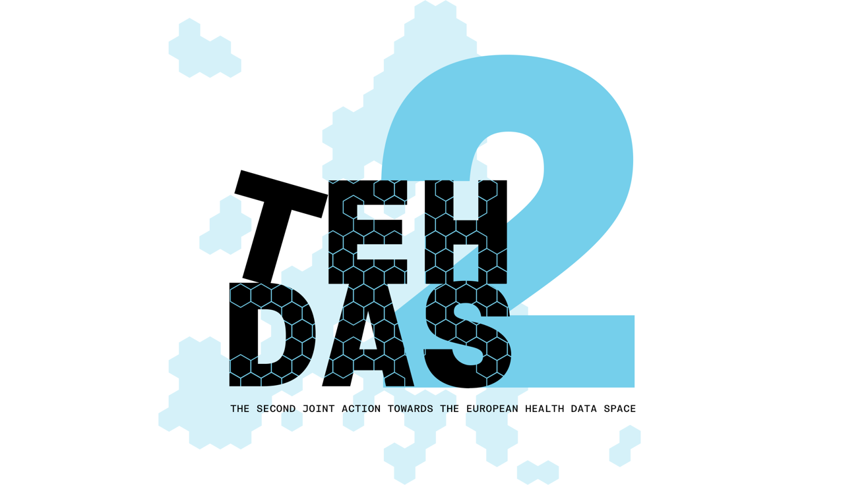

**M5.3 Draft technical specification on the national metadata catalogue – public consultation questions**

TEHDAS2 – Second Joint Action Towards the European Health Data Space

19 December 2024

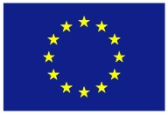**This project has been co-funded by the 4th EU Health Programme (2021–2027) under Grant Agreement no 101176773.**

**Disclaimer**

Views and opinions expressed in this deliverable represent those of the author(s) only and do not necessarily reflect those of the European Union or HaDEA. Neither the European Union nor the granting authority can be held responsible for them.

**Copyright Notice**

Copyright © 2024 TEHDAS2 Consortium Partners. All rights reserved. For more information on the project, please see [www.tehdas.eu](http://www.tehdas.eu).

**Contents**

1 Part A questions for generic feedback 3

1.1 Demography 3

1.2 Quality 3

1.3 Generic feedback 4

2 Part B questions for specific feedback 4

# Part A questions for generic feedback

These questions will be asked in each public consultation to provide an understanding of the recipients’ demographics, the quality of the document and to gather generic feedback. Questions marked with an asterisk are mandatory.

## Demography

**Country**\* [-List of countries-, EEA (Iceland, Liechtenstein and Norway, Europe non-EEA,European Organisation (European Commission, EMA, etc.), International Organisation (UN, WHO, etc.), Other]

**Type of the responder**\* [Public organisation, Private organisation, Non-governmental organisation (NGO), Academic or research institution, Interest group, Individual expert or professional, Patient representative, Individual citizen, Other]

**Sector**\* [Health care provider, Health care administration, Government/public administration, Research and development, Manufacturer of medical devices, Pharmaceutical industry, Education and academia, Information technology, Data management/processing, Patient advocacy, Legal and compliance, Information & media, Other]

**Organisation size**\* [Micro (1–9 employees), Small to medium enterprise (10–249 employees), Large enterprise (250+ employees), Not applicable/Individual citizen

**Professional role/function** [open text field]

## Quality

**From your perspective, how ready is the document to meet the expected needs?**\* [Early draft, Major additions/changes needed, Minor additions/changes needed, Only final editorial changes needed]

**What is the level of quality of the document?**\* [Rate 1 (Low) – 4 (Very High)]

**Is the document easy to understand?**\* [Rate 1 (not clear nor easy to understand) – 4 (very clear and easy to understand)]

**How well does the document address the key issues and challenges related to its subject matter?**\* [Rate 1 (not well) – 4 (very well)]

**How feasible and implementable do you find the guidelines or technical specifications presented in the document?**\* [Rate 1 (not feasible and implementable at all) – 4 (very feasible and implementable)]

## Generic feedback

**Do you have any suggestions for improving the document? Are there any additional topics or areas that should be covered?** [Please provide feedback and ideas for enhancing the document] [max. 750 characters]

# Part B questions for specific feedback

**Do you expect the technical specification for national dataset catalogue to affect you or your work?\*** [Yes, No, I don’t know]

**Do you find it clear which actors will be affected by the technical specification? If not, please explain your answer.** [Open text answer]

**Are the responsibilities of HDAB and Data Holders appropriately and clearly described? If not, please explain your answer.** [Open text answer]

**What are your thoughts on the terminology used in the document? Is it clear and appropriate for the context? Please explain your answer.** [Open text answer]

**Are the purposes and goals provided in section 3 clearly described? If not, please explain your answer.** [Open text answer]

**From your perspective, how do you perceive the scope of the specification outlined in section 4?\*** [Too narrow, Appropriate, Too wide, Unclear, Other (please specify)]

**Do you think the methods described in Annex 5 are appropriate for achieving the intended objectives? If not, please explain your answer.** [Open text answer]

**Are the user stories listed in section 5 appropriate and clearly described? Are there any user stories you believe are missing? Please explain your answer.** [Open text answer]

**Do you think the requirements listed in section 6 are appropriate and adequately categorised (e.g., mandatory, recommended, optional)? Are there any requirements you believe are missing? Please explain your answer.** [Open text answer]

**The document does not include specifications on non-functional requirements in section 6. Do you think non-functional requirement would be needed? If yes, please explain your answer.** [Open text answer]

**Are the capabilities outlined in section 7 adequate for the intended purpose? Are there any capabilities you believe are missing? Please explain your answer.** [Open text answer]

**What is missing from the specification for Member States to develop a national metadata catalogue? Please explain.** [Open text answer]